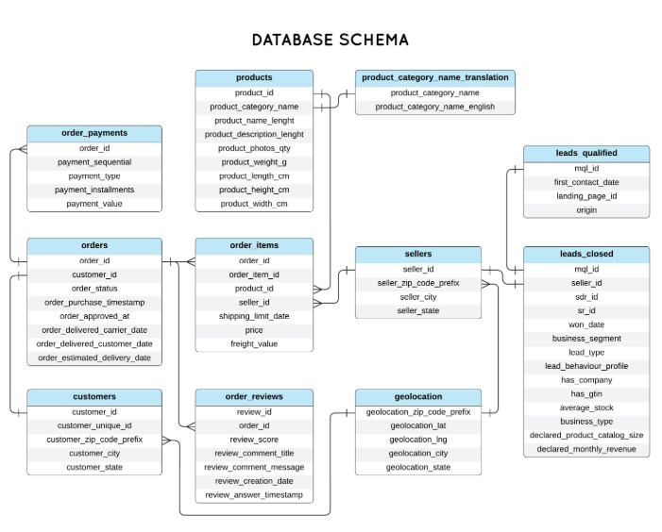

Leads_qualified
This table's general purpose is to store information on potential customers, known as leads, who have been identified by the marketing team as being a strong fit for the company's products or services. These leads, often called Marketing Qualified Leads (MQLs), have shown a higher level of interest than general leads, and this table serves to track them before they are handed off to the sales team.
Column Explanations
- mql_id: This is a unique identifier for a Marketing Qualified Lead (MQL). It acts as a primary key for the table and is used to track the lead throughout its journey.
- first_contact_date: The date when the company first made contact with the potential customer.
- landing_page_id: An identifier for the specific webpage or landing page that the lead interacted with, which helped qualify them.
- origin: The source of the lead, such as a specific marketing campaign, trade show, or social media platform.
Leads Closed Table
The purpose of this table is to track leads that have successfully gone through the sales process and have become a customer. This is the final stage of the sales pipeline, where a deal is "closed" or won. This table likely contains a more comprehensive record of the lead's final status and the details of the conversion.
Column Explanations
- mql_id: A foreign key that links back to the leads_qualified table, indicating which MQL successfully converted into a closed deal.
- seller_id: The identifier for the salesperson responsible for closing the deal.
- sdr_id: The identifier for the Sales Development Representative (SDR) who initially engaged with and qualified the lead before passing it on to a seller.
- sr_id: In a sales context, this likely refers to the Sales Representative ID.
- won_date: The date when the deal was officially closed and the lead became a customer.
- business_segment: The industry or market segment to which the new customer belongs.
- lead_type: The category of the lead, which could be based on their source or their behavior.
- lead_behaviour_profile: A categorization or profile of the lead's actions and engagement with the company's marketing materials.
- has_company: A boolean or flag indicating whether the lead is associated with a specific company.
- has_gtin: A boolean or flag indicating if the product or service sold to the lead has a Global Trade Item Number (GTIN), a unique identifier for products used in global trade.
- average_stock: The average inventory level of the product or service sold to the customer.
- business_type: The type of business the customer operates (e.g., B2B, B2C).
- declared_product_catalog_size: The number of products the new customer declared in their catalog.
- declared_monthly_revenue: The monthly revenue declared by the new customer.
What "qualified the lead" means
"Qualifying a lead" is the process of determining if a potential customer is a good fit for a company's product or service and is likely to make a purchase. This is a crucial step in the sales process to ensure that sales teams focus their time and resources on the most promising prospects, rather than wasting effort on those who are unlikely to convert.
Leads are typically qualified based on specific criteria, such as:
- Need: Do they have a problem that the product or service can solve?
- Budget: Can they afford the product or service?
- Authority: Do they have the power to make the purchasing decision?
- Timing: Are they ready to buy in the near future?
What is a Sales Development Representative (SDR) and what do they do?
A Sales Development Representative (SDR) is a sales professional who specializes in the initial stages of the sales process. Their main responsibility is to identify and qualify new leads and then book meetings for account executives to close deals.
SDRs act as the bridge between the marketing team and the sales team. Their primary tasks include:
- Prospecting: Researching and finding potential customers.
- Outreach: Making initial contact through cold calls, emails, and social media.
- Lead Qualification: Asking questions to determine if a lead meets the company's criteria to become a qualified prospect.
Hand-off: Passing qualified leads to a senior salesperson (often an Account Executive) to continue the sales process and close the deal.
What is "declared monthly revenue"?
"Declared monthly revenue" refers to the total amount of money a customer's business earns from its primary business activities in a given month. This is not the amount that the customer spent on the goods, but rather the revenue they themselves generate from selling their own goods or services.
This metric is often used to assess a customer's size and financial health, which can help a business decide if they are a good fit as a client. It is a gross figure, meaning it is the total money earned before subtracting any expenses.
Difference between three column of delivery_date
- order_delivered_carrier_date: This is the date the seller or e-commerce store hands off the purchased item to the shipping carrier. This marks the beginning of the shipping process from the carrier's perspective.
- order_delivered_customer_date: This is the actual date on which the customer received the order. This date is typically provided by the shipping carrier upon successful delivery and is used to confirm the order has been completed.
- order_estimated_delivery_date: This is an estimated date provided to the customer at the time of purchase. It is a projection based on factors like shipping speed, carrier information, and order processing time, and it may not be the same as the actual delivery date.
- orders_purchase_timestamp column refers to the exact date and time when a customer's order was placed or purchased.
Product Table
product_photos_quantity
In a products table, product_photos_quantity likely represents the number of images or photos available for a specific product. This column is useful for a number of reasons:
- Website Display: It tells the front-end of an e-commerce website how many images it should try to load for a product detail page.
Content Management: It can be used to monitor how many images have been uploaded for each product, ensuring that all products have an adequate number of photos to showcase them to customers.
Order_Items table
- freight_value: In an order_items table, freight_value refers to the cost of shipping a specific item. When an order contains multiple items, the total shipping cost is often split and assigned to each individual item in the order_items table. The total shipping cost for the entire order would be the sum of all the freight_value entries for all items in that order.
- shipping_limit_date: The shipping_limit_date is the deadline for the seller to ship the order to the logistics partner or carrier. This date is critical for managing fulfillment times and ensuring that orders are processed and shipped within the promised timeframe to meet customer expectations. It is an internal deadline for the seller to prevent delays in the delivery process.
Explanation of ER Diagram
The diagram is centered around the orders table, which acts as a central hub for all transactions.
- orders is connected to customers: This link shows which customer placed a specific order. The customer_id is the key that links a customer's personal details to their order.
- orders is connected to order_items: A single order can have multiple items. This link, using the order_id, shows which products belong to which order.
- order_items is connected to products: This link, using the product_id, shows the details of each item in an order, such as its name, category, and dimensions.
- order_items is connected to sellers: This link, using the seller_id, shows which seller provided a specific product in an order.
- orders is connected to order_payments: This link, using the order_id, stores the payment information for each order, such as the type of payment and value.
- orders is connected to order_reviews: This link, using the order_id, holds the feedback and review scores for each order.
Supporting Tables
- customers is connected to geolocation: This link, using the customer_zip_code_prefix, helps determine the geographical location of the customer.
- sellers is also connected to geolocation: This link, using the seller_zip_code_prefix, shows where the seller is located.
- products is connected to product_category_name_translation: This table, using the product_category_name, provides a translation of the product's category name into English.
Lead Management Tables
On the right side of the diagram, there are tables for managing potential customers, or "leads."
- leads_qualified is connected to leads_closed: This shows which qualified leads (mql_id) successfully converted into a customer and had their deal closed.
- leads_closed is also connected to sellers: This link, using the seller_id, shows which salesperson was responsible for closing a particular deal.
Please note that in this database states refers to states only in brazil not the countries of the world because this ecommerce is only brazil based.

